Advanced SQL Exercises for Online Retail Store
CREATE TABLE Products
(
ProductID INT PRIMARY KEY,
ProductName VARCHAR(100),
Category VARCHAR(50),
Price DECIMAL(10,2)
);
INSERT INTO Products
VALUES
(1,'Laptop A','Electronics',80000),
(2,'Laptop B','Electronics',75000),
(3,'Laptop C','Electronics',75000),
(4,'Mouse','Electronics',1500),
(5,'Chair A','Furniture',12000),
(6,'Chair B','Furniture',10000),
(7,'Chair C','Furniture',10000),
(8,'Table','Furniture',8000),
(9,'Book A','Books',1200),
(10,'Book B','Books',1000),
(11,'Book C','Books',1000),
(12,'Book D','Books',900);
SELECT * FROM Products;
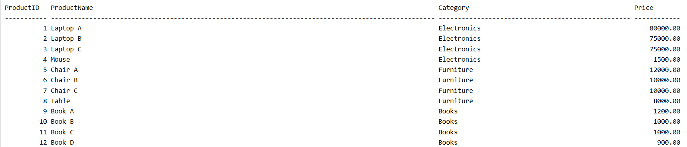
Exercise 1: Ranking and Window Functions
1.Use ROW_NUMBER() to assign a unique rank within each category
SELECT *
FROM
(
SELECT
ProductID,
ProductName,
Category,
Price,
ROW_NUMBER() OVER
(
PARTITION BY Category
ORDER BY Price DESC
) AS RowNum
FROM Products
) RankedProducts
WHERE RowNum <= 3;

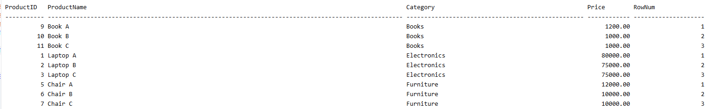

2.Use RANK() and DENSE_RANK() to compare how ties are handled.
SELECT *
FROM
(
SELECT
ProductID,
ProductName,
Category,
Price,
RANK() OVER
(
PARTITION BY Category
ORDER BY Price DESC
) AS RankNum
FROM Products
) RankedProducts
WHERE RankNum <= 3;
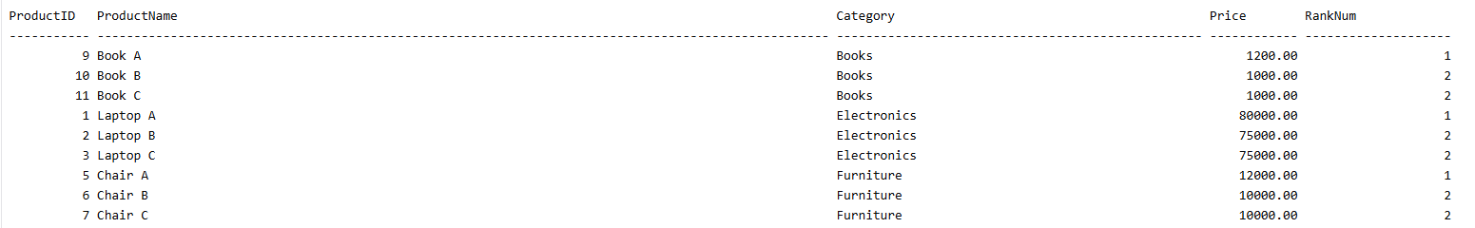

3. Use PARTITION BY Category and ORDER BY Price DESC.
SELECT *
FROM
(
SELECT
ProductID,
ProductName,
Category,
Price,
DENSE_RANK() OVER
(
PARTITION BY Category
ORDER BY Price DESC
) AS DenseRankNum
FROM Products
) RankedProducts
WHERE DenseRankNum <= 3;

